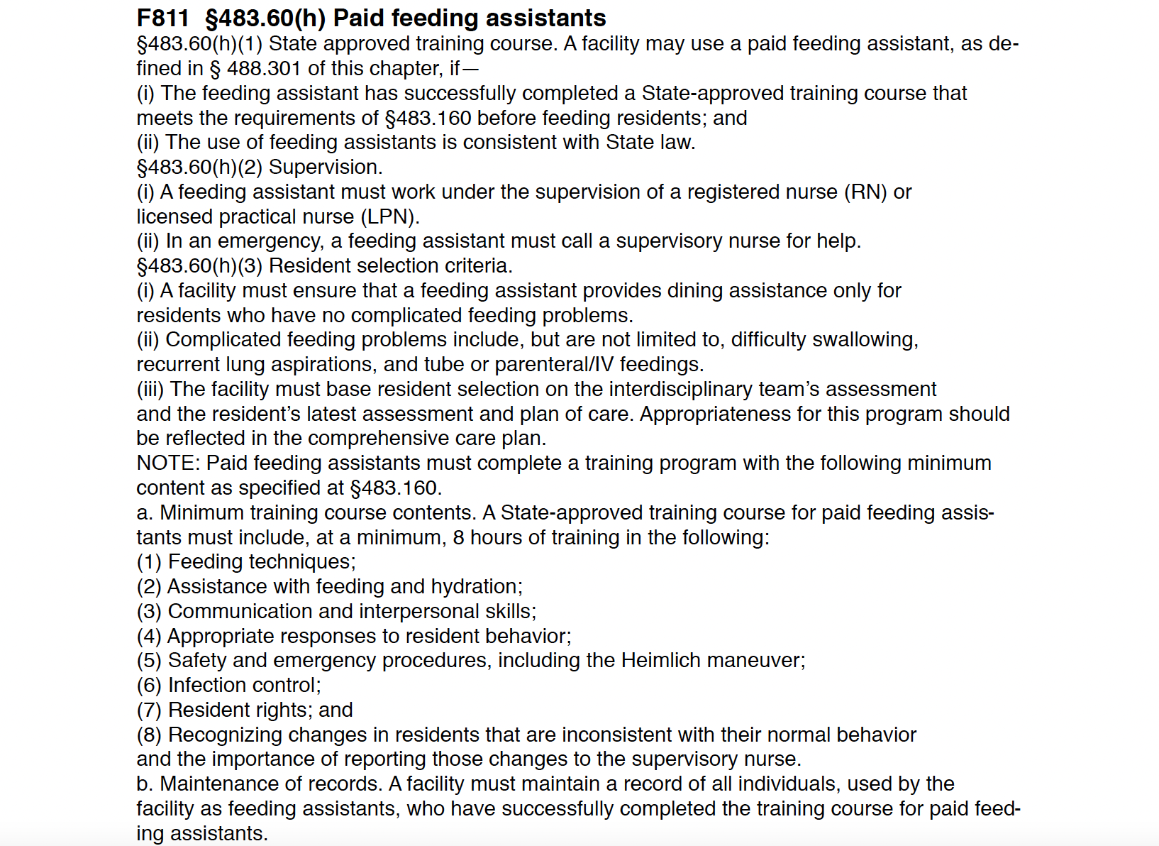

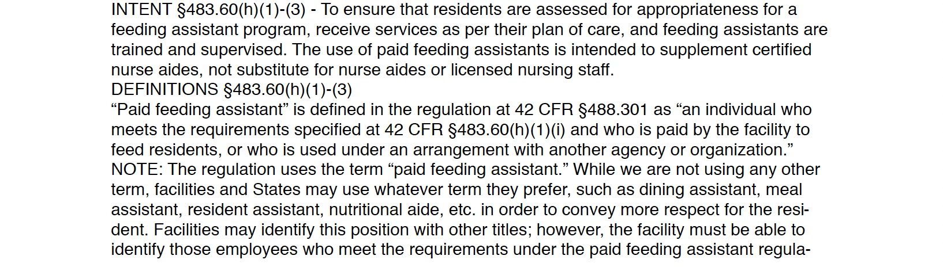

**Link to Temporary Feeding Assistant:**

[**https://educate.ahcancal.org/products/temporary-feeding-assistant#tab-product_tab_overview**](https://educate.ahcancal.org/products/temporary-feeding-assistant#tab-product_tab_overview)

**Link to the IHCA Paid Feeding Assistant course:**

[**https://www.idhca.org/events/snf-pd-fdg-assist-facilitation-course-now-available/**](https://www.idhca.org/events/snf-pd-fdg-assist-facilitation-course-now-available/)

**Here is the link to the AHCA website for the book to be used for the individuals who will be feeding residents:**

<http://www.ahcapublications.org/ProductDetails.asp?ProductCode=6778>

**Link for becoming a SNF Paid Feeding Assistant Trainer:**

[**https://www.idhca.org/events/snf-pd-fdg-assist-facilitation-course-now-available/**](https://www.idhca.org/events/snf-pd-fdg-assist-facilitation-course-now-available/)

Facility policy-

Ensure the facility has a policy-sample policy provided